Survey on Integrating Blockchain
with
Insurance and Healthcare industry

Dr. Shruti Jadon, Ashish Anand, Soham Panini, Parimala V, Rithika Pai

Department of Computer Science and Engineering, PES University, Bangalore, Karnataka, India

1 Abstract

The Healthcare industry as a whole has been evolving hand in hand with technologies prevalent in a specific time period revolutionizing the way the industry is perceived and the way it works. While Healthcare 1.0 was more doctor centric with paper prescriptions, we now have Healthcare 4.0 which brings in technologies like Cloud Computing and the Internet of Things into its fold thereby completely changing how the industry functions as a whole. Newer technologies are constantly being incorporated into the industry by the minute and thus the healthcare industry keeps on evolving. Blockchain technology is no exception and many researchers are finding new ways and approaches to bring it into the mix. The primary advantage of using blockchain is to help with data privacy and security. These advantages are of particular interest to the insurance industry which is very much interrelated to the healthcare industry in this day and age. It is this combination of healthcare, insurance, and blockchain that is explored in this survey paper extensively. The paper first looks at the relevant technologies for each stage of the healthcare industry from 1.0 to 4.0 then moves on to compare the relevant work done based on different schemes and then highlights the open issues and challenges with the current approaches.

2 Introduction
Healthcare and Insurance industries are two industries that are symbiotic in nature and how one functions has a huge impact on the functioning of the other industry. In today's age of privacy and security emphasis on these areas are of key importance and often is a deciding factor amongst various policies in driving sales. Thus, the prospect of integrating blockchain with these industries is quite lucrative as the key principles of blockchain are - privacy and security. Thus, in this paper, we have conducted a survey of many research papers trying to combine blockchain with either one of the industries or both in hopes that this paper proves to be a foundation for future generations to incorporate blockchain into the healthcare and insurance industries.

2.1 Scope

Many of the review papers published to date by different authors on the various security aspects of processing insurance claims specifically in the healthcare sector and reducing the number of fraudulent claims and claim disputes with the help of blockchain technology and smart contracts.
Most of the reviews as per the authors' knowledge have focused on a single or few security issues and have not explored the suitability of Blockchain to secure insurance claims and smart contracts. But, there is no exhaustive survey exists that considers all possible security vulnerabilities of the Healthcare insurance system. The proposed survey covers the background of the BC technology, smart contracts, healthcare insurance, and the integration of all three, along with
the taxonomy of security issues involved in the process. [1] has presented how BC can be used to resolve security and privacy issues in E-health Records. [5] has researched boosting IoT efficiency and security through the blockchain-based car insurance process. [12] presents blockchain-based privacy preserving healthcare architecture.[19] has done an exhaustive survey on security and privacy issues in healthcare 4.0. But, there is some literature available, which have not discussed the integration of BC technology and insurance claims. Authors in [22] focused on the computing for healthcare 4.0 environment, the opportunities found and challenges faced whereas [16] highlighted how blind signatures can be incorporated to modulate a secure e-healthcare system by using cloud computing. Later, DU, Xiaomin [10] focused on the architecture of smart contracts constructed for healthcare. J Gera. [9] and N R Bhamidipati et al. [11] described the fraudulent practices often observed in the insurance claim process and proposes a secure blockchain algorithm. Authors in [23] highlighted various frameworks on authentication and
privacy solutions for securing e-healthcare records.Mehta, [21] analyzed the recent research on Blockchain envisioned UAV networks and challenges, solutions, and comparisons of various algorithms proposed, whereas Kabre, Naman [14] proposed a blockchain-based framework for automated cheque clearance in financial institutions.
J. Hathaliya, P. Sharma [17] and R. Gupta[4] also explored blockchain-based remote patient monitoring and telesurgery frameworks for Healthcare. In [6], the authors created a generic model for multi-role Healthcare Data Sharing System. P.Purswani, [7] proposed blockchain-based parametric insurance.
To conclude, there are various papers that explore blockchain in the healthcare sector and various proposed algorithms but none of them have shown any proven results yet and there is more to explore under this technology in the future.

2.2 Motivation

Reducing the prevailing fraudulent methods and cumbersomeness in the health insurance sector is one of the key reasons to explore this. In the current ways, waiting for the reimbursement of insurance claims is tedious. To reduce the inefficiency in this, we try to introduce blockchain and smart contracts in the health insurance field. A blockchain-based health insurance scheme not only handles the existing privacy and security concerns but also reduces the uncertainty related to insurance in this fast-growing world. Making sure transparency is achieved by reducing the number of stakeholders using blockchain and smart contracts is a crucial advantage of looking at this survey. Improving the overall quality of health by making sure the capital needed for the same reaches those deserving of it is another reason to pursue this research.

2.3 Organization and the reading map of the paper

This section describes the structure of the survey paper. (some table number) lists all the abbreviations used in this paper. The rest of the paper is organized as follows. Section 3 provides the background on blockchain, Insurance, and healthcare as individual entities, and tries to establish an interdependent relationship that we will follow throughout the paper. Section 4 discusses the Review plan, including identifying Research questions and Data sources. In section 5, We described the architecture and its components in two parts, Basic and Advanced. In Section 6, We proposed the taxonomy based on integrating various technical aspects. A discussion on future research issues and challenges is presented in Section 7. Section 8 concludes the paper.
This paper is the first survey paper that combines all the three fields of healthcare, insurance, and blockchain together and tries to look for challenges common to the three fields.

3 Background

This section describes the background of blockchain, healthcare, and insurance industries. It is further divided into four subsections. The first subsection discusses the importance of blockchain and why we would be using it. In the second subsection, we define the evolution of technologies in healthcare starting from Healthcare 1.0 to Healthcare 4.0. The third subsection tells us how we plan on integrating healthcare and insurance using blockchain. The fourth section discusses the problem statement that this paper will be tackling.

3.1 What is blockchain and why blockchain?

To store and secure digital data, blockchain technology was first developed in 1991. Blockchain is basically a public ledger that many parties can view simultaneously. The fact that the information is recorded and difficult to change without consent from all parties is one of its main advantages. According to IBM, every new record turns into a block with a special hash for identification. A blockchain is created by connecting the blocks into a chain of documents. Any modification in one of the nodes results in the hash getting changed and the chain of nodes breaking. This ensures that no one can tamper with our chain of documents, keeping them safe. Blockchain facilitates the verification and traceability of multistep transactions that call for verification and traceability. Collaboration between network participants is made possible while an immutable audit trail of all interactions is recorded thanks to interactions with the Blockchain being known to all participants and requiring network authentication before any information is added.
The absence of a central administrator is one of the key factors that make blockchain technology used in healthcare. Why? mostly due to the fact that databases are physical objects made of bits and bytes. Anyone with access to the system may corrupt the data if the database contents were kept in the machine's physical memory. As Healthcare Digital services trade with confidential patient information and need fast access to information, Blockchain can streamline these medical records and securely enable their sharing. Blockchain simultaneously provides data privacy, scalability, and access security.

Although the concept of blockchain in healthcare is revolutionary today, problems with data management won't be solved by it. Instead, there would be a process of evolution where Blockchain is introduced gradually.

The major advantages of blockchain in healthcare are basically, Patient-centric electronic health records, Supply chain transparency, Patient data management/sharing, and crypto payments. 53 percent of healthcare executives believe that blockchain technology is one of their top five objectives, according to a recent survey. By 2025, technological investments in the global healthcare business will total $5.61
billion, predicts BIS Research. According to a report by IDC, by 2025, commercial blockchain technology would be used in 55% of all healthcare applications.

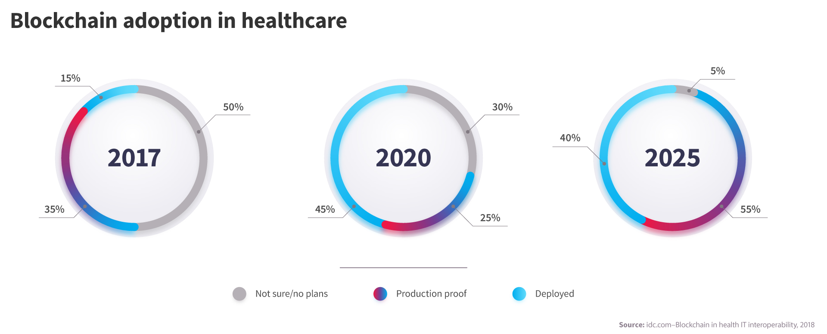

Fig 1: Adoption rate of Blockchain in Healthcare sector

3.2 HEALTHCARE ERAS
3.2.1 HEALTHCARE 1.0
Healthcare 1.0 or The Healthcare of the past as people call it, was a time when the industry was dominated by paper records, non-experimental, fixed set of practices and treatments. During such an encounter, a patient visits a clinic and meets with a physician and other members of the care team. Through consultation, testing, and diagnosis, the clinician (or care team) provide a prescription for medications and a care plan for treating a disease, as well as follow-up plans. The era was concentrated on the human side of healthcare as compared to the technological. It is mainly attributed to limited awareness about healthcare among people and the practitioners relied on the conventional method of care.

3.2.2 HEALTHCARE 2.0

Healthcare 2.0 is a concept that focused on technology as compared to human interaction. Along with major development in health, life science, and biotechnology, numerous new medical equipment and devices have been invented, developed, and tested, and are increasingly used in health care delivery. For instance, imaging test equipment (e.g. MRI, ultrasound, CT scan), monitoring devices (e.g. pulse oximeter, arterial lines), and surgical and life support equipment (e.g. da Vinci robot, chest tubes) are increasingly used in hospitals and other care settings to support diagnosis, treatment, and monitoring. We refer to this development as Health Care 2.0.

3.2.3. HEALTHCARE 3.0

Healthcare 2.0 has become a version that has reduced the human interaction to an extent that now technology has taken the dominant seat in every process.This lack of human connection in an industry that depends greatly on empathy and doubts is what has now been laying the foundation of Healthcare 3.0. In conjunction with the development of information systems, electronic health or medical records (EHR or EMR) have been implemented to manage care of patients across units and departments of health care organizations; these health information technologies have had major impact on clinical and operational processes. Numerous activities are time-stamped and recorded in the EHR, and many manual processes have been computerized and digitalized . In addition, using available computer networks, remote care and telehealth have become possible, and electronic visits are beginning to replace some face-to-face encounters. All of these have led to multifarious revolutionary changes in health care delivery. The 3.0 era focuses on technology being used to take care of patients and saving time for medical practitioners.

3.2.4 HEALTHCARE 4.0

This is where our approach falls under. The fourth health care revolution is now developing and being followed. In such a context, the health care delivery process becomes a cyber-physical system equipped by IoT, RFID ,wearables, and all kinds of medical devices, intelligent sensors, medical robots, etc., which are integrated with cloud computing, big data analysis, artificial intelligence, and decision support techniques to achieve smart and interconnected health care delivery. In such a system, not only the health care organizations and facilities are connected; but also all the equipment and devices, as well as the patients’ home and communities are linked together. Patient-related information, e.g. medication history, diagnostic notes, lab results, treatment plans, pharmacy refills, billing, and insurance claims, can be potentially shared through adequate protocols. In addition, through AI techniques, we can envision proactive treatment, disease prediction and prevention, personalized medicine, and enhanced patient-centered care. Thus, a pervasive, smart, and interconnected health care community emerges, which leads to the paradigm of Health Care 4.0.

3.2.5. HEALTHCARE ERAS

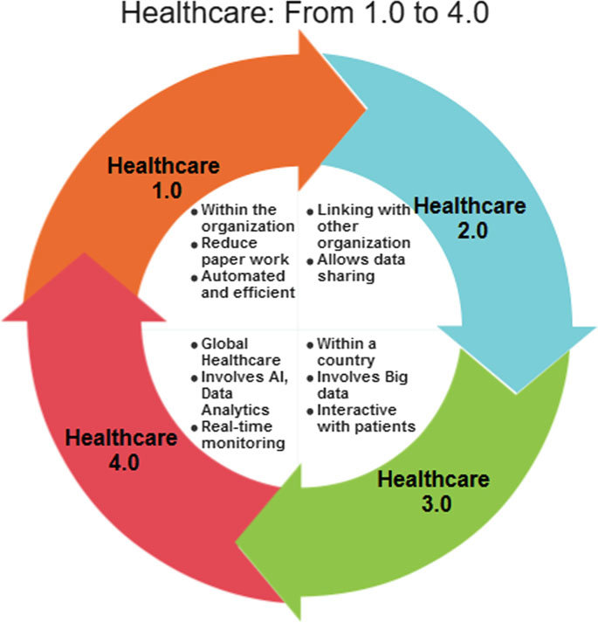
Fig 2: Healthcare Eras
3.3 Why healthcare and insurance using blockchain?

A good healthcare system goes a long way in contributing to the progress of a country’s economy. The insurance sector in India helps in the mobilization of savings. Huge funds are accumulated which are then invested in several ways, thus substantially contributing to the economic growth. Health insurance is the second-largest contributing segment to the Indian general insurance industry. Using blockchain in health insurance can potentially solve the most widespread challenges related to the non-standardization and interoperability of healthcare information. A blockchain network can be used in the healthcare system to exchange and preserve patient data through hospitals, pharmacy firms, and diagnostic laboratories. Severe dangerous mistakes can be identified using blockchain applications. Apart from contributing to the economy, the chosen research helps in saving lives and reducing complexities in the health and insurance sector. The Indian health insurance ecosystem consists of multiple key stakeholders. The interaction between these stakeholders often involves an intense exchange of data and is complicated. Blockchain and smart contracts could be the ideal way to execute transactions and maintain records through the participation of all stakeholders in an accountable way.

3.4 Problem Statement

“Integration of blockchain technology with healthcare and insurance industry”. There are many papers for the three categories separately, and also for integrating any two of the three categories like in [5] the authors are trying to explore the possibilities of integrating blockchain and IoT technologies with the insurance industry to automatically detect and verify accidents reliably. In [23] the authors try to achieve a balance between data privacy and ease of data accessibility by proposing a blockchain-based framework for accessing electronic health records and giving the users control over who can access their records. In [9] the authors try to tackle fraudulent claims occurring usually in the audit phase of insurance claiming procedure by storing medical records on blocks thereby making them immutable once they are uploaded. In [4] the authors have proposed a framework for secure robotic telesurgery which utilizes smart contracts to remove the roles of intermediates involved in telesurgery and also by utilizing blockchain they reaffirm the security and privacy aspects involved. In [7] the authors explore the concept of parametric insurance in the healthcare domain by implementing insurance policies as a smart contract, the paper establishes a proof of concept for introducing the parametric approach to insurance in healthcare. In [11] the authors try to make a platform for processing insurance claims, particularly emphasizing the security aspects of utilizing blockchain in the claim processing platform, they also utilize smart contracts to maintain costs and improve the processing time for claims.

4.0 Review method

The proposed survey's review method is split into 6 subsections namely, Review plan, Research questions, Data sources, Search Criteria, Criteria of inclusion and exclusion, and Quality evaluation

4.1 Review plan

The proposed survey starts with the identification of the research questions (RQ), data sources, database search criteria, criteria for inclusion and exclusion method of the databases, and quality evaluation. Identification of relevant publications and studies is done for the systematic survey. This material is first checked for quality, and only then relevant data is extracted for the proposed survey. A well-defined survey helps minimize researcher biases.

4.2 Research Questions

The proposed survey Integrates blockchain with Healthcare and Insurance industries. The RQs and their objectives used for the systematic survey are listed in Table 1.

Q. No. | Identified Research Questions | Objective
RQ. 1 | How the integration of blockchain with healthcare and insurance industries would be beneficial to people? | It aims to find out the means by which blockchain Integration would result in better collaboration between health professionals to provide complete treatment, resulting in overall well-being.
RQ. 2 | How can blockchain solve interoperability between healthcare and insurance industries better than today’s existing methods? | It aims to get knowledge about two factors namely, Security and the ability to establish trust between entities.
RQ. 3 | Discuss various taxonomies and comparative analyses of various surveys on the Integration of blockchain with the healthcare and insurance industries. | Various taxonomies and comparative analyses based on an existing survey of Blockchain, Healthcare, and insurance industries, are used to understand the pros and cons of the integration of blockchain with healthcare and insurance industries.
RQ. 4 | How can we detect fraud more effectively? | It aims to use the features of blockchain-like immutability and Consensus mechanisms to determine if the information is valid or not.
RQ. 5 | How the data would be stored on the blockchain? What will be its merits? | Our objective here is to store EHR securely on smart contracts over the blockchain. Aims to provide greater transparency than cloud providers.
Table 1:Research Questions

4.3 Data sources

For a comprehensive survey, we need a broad overview. To search the existing information, we used digital libraries like Springer, researchgate, IEEEXplore, and Science Direct, and the electronic data sources recommended in [21]

Other resources: Apart from the above-mentioned sources, patents, reports, technical books, and online literature related to the already existing surveys are included for our research purposes.

4.4 Search Criteria

In this criteria, search using keywords like ‘‘Blockchain based Health Insurance’’ and other related keywords as shown in Fig. Many research papers have not been found by considering the search string shown in Fig because sometimes the search string is not present in the abstract and title. To identify such papers, the manual searching process has been done for the papers with given keywords in digital sources.
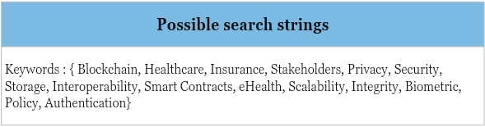
4.5 Criteria for inclusion and exclusion

Healthcare, Insurance, and blockchain have many papers for integrating two out of the three fields and also a few papers which integrate all three. Searching for the string “healthcare insurance blockchain” results in some form of blockchain-based fraud detection for health insurance and some other irrelevant papers which makes filtering relevant papers a somewhat difficult task. Papers from 2017 onwards have been taken for this survey. The papers were chosen generally fall under any two of the chosen three fields, however, there are some papers exclusive to a single field for greater coverage.

4.6 Quality Evaluation

In this survey, quality evaluation has been performed on the papers. This paper adds an overview on intergrating blockchain with insurance and healthcare industry. This paper has also discussed in detail the various schemes which are used to compare other papers in this field.

5. Architecture and its components

Here in this section, we have discussed the architecture for our own platform “InsuraChain” that brings together blockchain with the healthcare and insurance industry. Our model tries to simplify and synchronize the three, to assimilate all the useful properties of blockchain and also simplify the final product for all the stakeholders concerned.

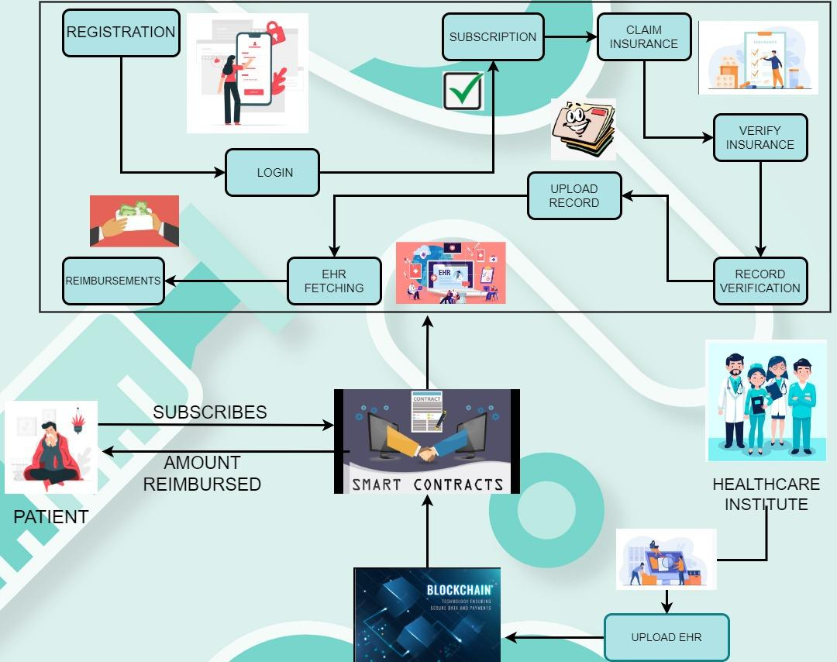
Fig 3: Architecture

5.1 Architecture (basic)

In this paper, we divide the flow of data based on the stakeholders involved i.e the patient, insurance company (insura-chain), and the healthcare institutes.
The patient subscribes to the insurance and pays the due amount monthly and when required applies for an insurance claim against a particular medical record, his claim request is processed by the smart contracts as shown in the figure.
The Healthcare institutes are responsible for uploading the medical records of each patient which are used for verification against the claim issued by the patient. Each record is uploaded by authorized personnel thereby assuring the correctness of the medical record.
The insurance company has the frontend where the user can register/login for issuing claims, they utilize the smart contracts for verifying if the claim issued is correct or not, and if the claim is correct then which payment slab the claim falls under. Based on this the amount is given back to the patient.

5.2 Architecture (Advanced)

Some of the components used in the blockchain-based architecture, as shown in figure {random number} are already discussed in the basic architecture. We are using a hybrid model of blockchain, Meaning some of the data on the blockchain would be public while the other would be private. The public data here is being referred to the basic details of the hospitals, like Hospital name, doctors, their specialization, total beds, occupancy, etc. The private data here is being referred to the private details of the patients like their name, address, diseases he was infected with, past history of medical treatment, etc.
Our model, also sends a notification to the users’ mobile, when a claim is accepted or rejected based on the decision made by the smart contracts.

6. Schemes

In this section, we have compared and contrasted the various papers we have considered for the conduction of the survey based on different parameters or schemes. This helps us gain a clear understanding of the actual benefits of incorporating different technologies and the challenges faced while doing so. These different schemes help us in exploring the degree and extent of integration of technologies and industries existing in the present time and thereby provide meaningful insights for further integration in the future

Scheme - 1, Based on accessibility and data transparency

According to a survey conducted by the CDBC Blockchain research institute, Industrial production use cases are expected to grow by double-digits in 2021. However, Different types of blockchain are required for different types of use cases.

There are majorly 4 types of blockchain, based on accessibility namely: Public blockchain, Private blockchain, hybrid blockchain, and consortium blockchain. Each Blockchain technology has its own pros and cons.Table 2 compares the papers based on accessibility and data transparency and also lists their pros & cons.

6.1) Public Blockchain - The first type of blockchain is the public blockchain. It is permissionless and non-restrictive, so anyone with the internet can sign in to a blockchain to become a part of the network. Each node in this blockchain network would have full access to the data that is being stored in the blockchain. Each node will also be able to see all the past transactions.

6.2) Private Blockchain - A blockchain network that operates in a restrictive environment like in a closed network or is under the control of a single entity is called a private blockchain. This technology uses peer-to-peer connections and decentralization, and it is also on a much smaller scale as compared to the public blockchain. Only the nodes which are part of the private network would be able to see the data.

6.3) Hybrid Blockchain - A blockchain network that has the best of both worlds - public and private will use a Hybrid blockchain. It lets an organization set up a private, permission-based system along with a public permissionless system, allowing them to control permissions for the data stored in blockchain, whether to make it public or keep it private. In this technology, A recently joined user has full access to the network, but their identity is protected from other users. When the recently joined user engages in a transaction, then only their identity is revealed to the other party.

6.4) Consortium Blockchain - The fourth type of blockchain is the consortium blockchain. It is very similar to a hybrid blockchain in the sense that it has both private and public blockchain features. The major thing that separates a consortium blockchain from a hybrid blockchain is that multiple organizational members collaborate on a decentralized network.
In a consortium blockchain, the consensus is controlled by present nodes. It has two major nodes - validator nodes and member nodes, Former’s task is to initiate, receive, and validates transactions, latter’s task is to receive and initiate transactions.

Author | Year | Objective | Type of Blockchain
Anuj S  et. al. [8] | 2021 | Building a blockchain-based healthcare insurance system | Etherium (Public)
Salam Khanji  et. al [5] | 2019 | Integrating blockchain and IoT technologies with the insurance industry by using car insurance as a case study | Etherium (Public)
Dr.Jaideep Gera  et. al. [9] | 2020 | Detecting Fraudulent practices in insurance claims | Hyperledger Fabric (Private and Consortium)
Jayneel Vora  et. al. [1] | 2018 | Building a framework for achieving a balance between security and privacy for EMRs/EHRs. | Ethereum (Public)
Xiaomin Du et. al. [10] | 2021 | This paper aims to explore the application of blockchain technology in smart healthcare and reveal the impact of blockchain on smart healthcare. | Different factors use different types of blockchain.
Naga Ramya Bhamidipati et. al. [11] | 2021 | Proposing an intelligent insurance claim processing system that replaces NICB/ISO Architecture. | Consortium Blockchain
Sudeep Tanwar et. al. [13] | 2019 | Propose a framework named BloHosT,  which allows tourists to interact with various stakeholders  through a single wallet identifier linked with a cryptocurrency  server to initiate payments. | Public Blockchain
Naman Kabra et. al. [14] | 2019 | This paper proposes a blockchain called mudrachain that provides trust in a distributed environment for security clearance of cheques. | Consortium Blockchain
Koosha Mohammad Hossein, Mohammad Esmaeil Esmaeili [12] | 2019 | Blockchain-Based Privacy-Preserving Healthcare Architecture | Hybrid Blockchain
Yao Yu, Qirui Li [6] | 2020 | This paper proposes a Blockchain-Based Multi-Role healthcare data sharing systems using IPFS and smart contracts for claim and storage of the insurance. | Consortium Blockchain
Rajesh Gupta, Sudeep Tanwar, Sudhanshu Tyagi [4] | 2019 | HaBiTs: Blockchain-based telesurgery Framework for Healthcare 4.0 | Consortium Blockchain
Peng Zhang, Jules White [24] | 2017 | Metrics for Assessing Blockchain-based Healthcare Decentralized Apps | Hybrid Blockchain
Table 2: Based on accessibility and data transparency

SCHEME-2, based on different consensus mechanisms
A consensus mechanism is a mechanism used in blockchain in order to arrive at consensus i.e. the way in which the blockchain achieves a single state of network among the nodes which are distributed. Basically, these are protocols for synchronization and agreement on transactions. Table 3 compares the consensus model used by different papers and also lists their pros & cons.

Author | Year | Objective | Blockchain used | Consensus Mechanism | Pros | Cons
Anuj S  et. al. [8] | 2021 | Building a blockchain-based healthcare insurance system | Hyperledger Fabric | PoW | A permissioned blockchain with Ma-ABS helps to ensure privacy, security & confidentiality for sensitive data. | With increasing data, it becomes difficult to scale the model on permissioned blockchain due to the high costs involved.
Salam Khanji  et. al [5] | 2019 | Integrating blockchain and IoT technologies with the insurance industry by using car insurance as a case study | Etherium | PoA, PoS | The consensus mechanism used provides reliability in claim processing and also have the added benefits of blockchain like security, privacy, etc. | IOT devices generate a lot of data and have limited computing capacity(spare), this makes integrating these devices with blockchain a difficult task and also ensuring the safety and reliability of IoT devices present a challenge.
Dr.Jaideep Gera  et. al. [9] | 2020 | Detecting Fraudulent practices in insurance claims | Hyperledger Fabric | SOLO | SOLO mechanism is often used by developers for testing purposes and helps in building prototypes as is the case in this paper. | SOLO has a single ordering node that fails to simulate the production environment settings and hence it is often not used.
Jayneel Vora  et. al. [1] | 2018 | Building a framework for achieving a balance between security and privacy for EMRs/EHRs. | Ethereum | PoW | PoW ensures the new node added is trusted. | PoW does not cater to ease of access use cases in particular.
Naga Ramya Bhamidipati et. al. [11] | 2021 | Proposing an intelligent insurance claim processing a system that replaces NICB/ISO Architecture. | Consortium Blockchain | PoW | Smart contracts ensure if the claim is valid/invalid. To commit actions it follows the principle of an orderer. | Proof of Work blockchains provide adequate security only if there is a large network of miners competing for block rewards, but this is not happening in this case.
M. Thenmozhi [2] | 2021 | helping insurance companies to securely develop a  blockchain medium for claim processing in insurance by using smart contracts | Hyperledger Fabric | Tamper Free System | Smart contracts to ensure if the claim is valid/invalid. | In this model, the database they are using is not encrypted.
Sudeep Tanwar et. al. [13] | 2019 | Propose a framework named BloHosT,  which allows tourists to interact with various stakeholders  through a single wallet identifier linked with a cryptocurrency  server to initiate payments. | Public Blockchain | PoC | Traveler Identity verification, Baggage and asset tracking, Avoid overbooking | Expensive mining process since the database for tourism is humongous.
Naman Kabra et. al. [14] | 2019 | This paper proposes a blockchain called mudrachain that provides trust in a distributed environment for security clearance of cheques. | Consortium Blockchain | PoA | Very low demand on the computing power of users,  the Transaction time of PoA is significantly faster than the transaction time of PoW. | Its networks strongly lack decentralization. In contrast to PoW, PoA blockchain can have only a limited number of validators
Yao Yu, Qirui Li [6] | 2020 | Blockchain-Based Multi-Role healthcare data sharing systems | Consortium Blockchain | Proof of Work | This proposal gives high security and decentralized method of varyfying transactions. | Requires high energy and expensive fees.
Koosha Mohammad Hossein [12] | 2019 | Blockchain-Based Privacy Preserving Healthcare Architecture | Hybrid Blockchain | Practical Byzantine Fault Tolerance | This architechture is optimized for low overhead time and the transactions donot need multiple confirmations. | This mechanism is susceptible to sybil attacks.
Rajesh Gupta, Sudeep Tanwar, Sudhanshu Tyagi [4] | 2019 | HaBiTs: Blockchain-based telesurgery Framework for Healthcare 4.0 | Consortium Blockchain | Proof of Work | the model is characterized by mathematical equations, which the nodes , or miners, on a network essentially race to solve. | it means solving the equation in a reasonable amount of time requires an exceptional amount of computational power.
Peng Zhang, Jules White  [24] | 2017 | Metrics for Assessing Blockchain-based Healthcare Decentralized Apps | Hybrid Blockchain | Proof of Work | This approach is extremely secure. | This model requires increasingly fast computers, the use of significant energy resources, and processes that eventually slow down transaction times
Table 3: Based on Consensus Mechanism

Scheme - 3, Based on what kind of data can be stored on the blockchain
Data is the most critical unit of blockchain. A crucial task is storing, processing, and analyzing data, and new technologies are developing to make the process as simple as feasible. There are basically two methods for storing data via blockchain on-chain and off-chain.
In the on-chain method, All the data is stored inside each block of the blockchain. Thus, if an attack happens, data can be restored and used, but this method is costly because the network and data might get overloaded.
In the off-chain method, it doesn't store the entire data, but only the metadata. The major disadvantage is that if a system breach happens, data might not get restored.

The major data types that can be stored on blockchain are Hash, Links, Transactions, EMR-EHR, etc.
Table 4 compares the papers based on the data that is stored.

Author | Year | Objective | Data stored off-chain/on-chain | What kind of data is stored?
Anuj S  et. al. [8] | 2021 | Building a blockchain-based healthcare insurance system | on-chain | Medical Records
Salam Khanji  et. al [5] | 2019 | Integrating blockchain and IoT technologies with the insurance industry by using car insurance as a case study | on-chain | FIRs
Jayneel Vora  et. al. [1] | 2018 | Building a framework for achieving a balance between security and privacy for EMRs/EHRs. | off-chain | Medical Records
Jigna J  et. al. [3] | 2019 | Monitoring vitals with smart wearables and authenticating the data with biometrics | off-chain | Medical Records
Naga Ramya Bhamidipati et. al. [11] | 2021 | Proposing an intelligent insurance claim processing a system that replaces NICB/ISO Architecture. | on-chain | Insurance Records
M. Thenmozhi [2] | 2021 | helping insurance companies to securely develop a  blockchain medium for claim processing in insurance by using smart contracts | off-chain | Client data, Insurance details
Sudeep Tanwar et. al. [13] | 2019 | Propose a framework named BloHosT,  which allows tourists to interact with various stakeholders  through a single wallet identifier linked with a cryptocurrency  server to initiate payments. | on-chain | Financial data
Naman Kabra et. al. [14] | 2019 | This paper proposes a blockchain called mudrachain that provides trust in a distributed environment for security clearance of cheques. | off-chain | Transactions
Peng Zhang, Jules White [24] | 2017 | Metrics for Assessing Blockchain-based Healthcare Decentralized Apps | On chain | Encrypted metadata to refer to actual patient health information.
Rajesh Gupta, Sudeep Tanwar, Sudhanshu Tyagi [4] | 2019 | HaBiTs: Blockchain-based telesurgery Framework for Healthcare 4.0 | On chain | Details of patient, surgeon and caregiver
Koosha Mohammad Hossein [12] | 2019 | Blockchain-Based Privacy-Preserving Healthcare Architecture | On chain | hash of patient’s healthcare data
Yao Yu, Qirui Li [6] | 2020 | Blockchain-Based Multi-Role healthcare data sharing systems | Off chain | Insurance claim contracts
Jayneel Vora, Sudeep Tanwar [16] | 2018 | Blind Signatures based secured E-healthcare system | Off chain | Multiple EHR’s.
Table 4: Based on Data stored

Schemes - 4, Based on different encryption types-
Blockchain encryption is the process of encrypting the data from “plaintext” into “ciphertext” using a dedicated crypto algorithm. Blockchain cryptography enables two parties to conduct a transaction without disclosing any personal information or involving a middleman. Different types of blockchain use different types of encryption namely- Symmetric encryption, Asymmetric encryption, and hashing.
Table 5 compares the papers based on their encryption types.

4.1) Symmetric encryption- The first type of encryption refers to symmetric-key encryption. It focuses on using similar keys for encryption as well as decryption of data. It is also known as secret-key cryptography.

4.2) Asymmetric encryption- The second type of encryption that has a massive role in the applications of cryptography in the blockchain is asymmetric key encryption. Asymmetric encryption is also referred to as public key cryptography and involves the use of public and private keys for encryption and decryption respectively. Key pairs are created via asymmetric-key cryptography methods, where the public key is shared publicly while the private key is kept private.

4.3) Hashing- Cryptographic hashing is the most fundamental and basic component of blockchain technology. Hashing enables the most significant feature in the blockchain, i.e Immutability. The encryption through hashing does not involve the concept of keys. Hashing leverages an algorithm for obtaining a hash value(fixed length) by taking a string of any length as the input. The use of the SHA-256 cryptographic hash function is the most widespread application of hashing in blockchain technology.

Author | Year | Objective | Type of encryption | Which Algo used?
Jigna J  et. al. [3] | 2019 | Monitoring vitals with smart wearables and authenticating the data with biometrics | Asymmetric | Elliptical curve cryptography
Jayneel Vora  et. al. [1] | 2018 | Building a framework for achieving a balance between security and privacy for EMRs/EHRs. | Both Symmetric and Asymm/etric | PKI
Salam Khanji  et. al [5] | 2019 | Integrating blockchain and IoT technologies with the insurance industry by using car insurance as a case study | Symmetric | AES
Sudeep Tanwar et. al.  [13] | 2019 | Propose a framework named BloHosT,  which allows tourists to interact with various stakeholders  through a single wallet identifier linked with a cryptocurrency  server to initiate payments. | Asymmetric | ZKP
Naman Kabra et. al. [14] | 2019 | This paper proposes a blockchain called mudrachain that provides trust in a distributed environment for security clearance of cheques. | Assymetric | ABE
Yao Yu, Qirui Li [6] | 2020 | Blockchain-Based Multi-Role healthcare data sharing systems | Asymmetric | ECC
Koosha Mohammad Hossein, Mohammad Esmaeil [12] | 2019 | Blockchain-Based Privacy-Preserving Healthcare Architecture | Hashing | SHA
Rajesh Gupta, Sudeep Tanwar [4] | 2019 | Blockchain-based telesurgery Framework for Healthcare 4.0 | Symmetric | DES
Table 5: Based on Encryption types
SCHEME-5, Wearable device-based schemes
Wearable devices are small computing devices that people wear on their bodies. With the advancement in computing power and the rise of Cloud computing technologies these devices have become smarter with time and are now capable of tracking the vitals of their wearers. Some examples of such devices are- the Apple smartwatch, Fitbit fitness trackers, etc. These devices can monitor heart rate, body temperature, no. of steps taken, etc which can be used as vital input for the algorithms that run on the cloud for detecting any abnormalities and onset of diseases and in some cases detect the diseases or medical conditions even before the onset of physical symptoms and thus save lives. Such data generation however leads to privacy and data security concerns which can be solved by blockchain. Table 6 shows the papers which have these wearable devices in some form or other.

Author | Year | Objective | Wearable Device | Connected to | Pros | Cons
Jigna J  et. al. [3] | 2019 | Monitoring vitals with smart wearables and authenticating the data with biometrics | Smartwatch,glass and socks | Smartphone app | The wearable devices can collect vital information 24X7. | The devices are not independently connected to a cloud server meaning if the phone goes down so does the monitoring of data.
Yao Yu, Qirui Li [6] | 2020 | Blockchain-Based Multi-Role healthcare data sharing systems | sensors that collect information about blood pressure etc., | Smartphones and devices | Wearable devices collects all the basic information from patient that is required at the time of diagnosis | The wearable devices donot usually have a backup storage so if the device stops working then we have lost all data.
Koosha Mohammad Hossein [12] | 2019 | Blockchain-Based Privacy-Preserving Healthcare Architecture | sensors | smartphone | The sensors collect the basic necessary information about the health of the patient which is required at some point in the diagnosis | The sensors have very low security mechanism and hence can easily be hacked and the data can be under many attacks and inevitable users.
Table 6: Based on Wearable devices
SCHEME-6, based on security mechanisms/methods
The security mechanisms or methods are used to ensure data confidentiality, privacy, and data integrity. These are essential for access control of data i.e. who can view which section of data and which section of data or details are hidden from certain people. Different papers implement these security mechanisms differently to achieve different goals as listed in Table 7, which is given below.

Author | Year | Objective | Security Mechanism | Consensus Mechanism | Pros | Cons
Jigna J  et. al [3] | 2019 | Monitoring vitals with smart wearables and authenticating the data with biometrics | Biometric | - | The biometric approach taken here is using fingerprints for authenticating new devices which have high reliability. | The fingerprint is only used when registering a new wearable device.
Anuj S  et. al. [8] | 2021 | Building a blockchain-based healthcare insurance system | Ma-ABS | PoW | The records generated can only be signed or viewed by authorized personnel each having their own unique attribute-based signature. | With multiple authorities or people being involved the risk of any one personnel committing fraudulent activity increases.
Jayneel Vora  et. al. [1] | 2018 | Building a framework for achieving a balance between security and privacy for EMRs/EHRs. | Smart contract-based | PoW | The owner contract and permission contract help in restricting the access of records to other people. | While the smart contracts do handle the security aspect they do not contribute to ease of data access at all but rather introduce more steps in between.
Naga Ramya Bhamidipati et. al. [11] | 2021 | Proposing an intelligent insurance claim processing a system that replaces NICB/ISO Architecture. | Smart contract | PoW | It applies three Security mechanisms namely- Hardening, Sufficient Documentation, and Principle of privilege Attenuation | For Testing the security side, They use a fraud model but since the fraud model trains on a limited dataset. It won't be able to detect new types of attacks
Yao Yu, Qirui Li [6] | 2020 | Blockchain-Based Multi-Role healthcare data sharing systems | Smart- contract based | PoW | The smart contract can only be accessed through a pair of keys, hence without right verification the data cannot be accessed. | Public key operations become difficult while following this algorithm, and binary curve can be difficult to compute.
Koosha Mohammad Hossein [12] | 2019 | Blockchain-Based Privacy-Preserving Healthcare Architecture | CIA triad scheme | PBFT | Applying the principles of the CIA triad helps organizations create an effective security program to protect their valuable assets. | organizations measure the risks, threats and vulnerabilities that could compromise the confidentiality, integrity and availability of their systems and data.
Jayneel Vora, Sudeep Tanwar [16] | 2018 | Blind Signatures based secured E-healthcare system | cloud computing |  | Easy accessibility and reliability. The data is backed up and secured. | This requires a good internet connection, since its a public cloud attacks will be easier.
Rajesh Gupta, Sudeep Tanwar [4] | 2019 | Blockchain-based telesurgery Framework for Healthcare 4.0 | secret key cryptography | PoW | the system only needs to perform a single, reversible mathematical equation to encrypt or decrypt a file, the process is almost transparent A different secret key is used for communication with every different party. Only the messages between a particular pair are affected if a key is compromised. | The number of keys required for communication among parties is too large as a different secret key is used for communication with every different party.
Peng Zhang, Jules White  [24] | 2017 | Metrics for Assessing Blockchain-based Healthcare Decentralized Apps | Turing-complete operations | Pow | Turing complete operation is considered the most powerful mechanism and this being executed will make the system very secure and prevent it from any attack. | This operation is very difficult to achieve and will cost a lot of computational power.
Table 7: Based on Security Mechanisms

Scheme - 7, Based on Processing-
The rapid growth of the Healthcare and Industrial industries has resulted in generating huge amounts of data, which we today call Big Data. This huge amount of data when transmitted over the internet is a challenging issue in Cloud computing, Fog computing, and mobile edge computing. There are majorly 3 types of processing types namely - Distributed scenario, Centralized scenario, and Decentralized scenario.
Table 8 compares the paper on this scheme.

7.1) Distributed Scenario - The first type of scenario is the distributed scenario which is very much similar to a decentralized network in the sense that it irradicates the need for a single centralized master/server node. Distributed networks, however, are made up of equal, interconnected nodes, thus data ownership and processing resources are distributed equally across the network as a whole. Due to the absence of a central server and a separate set of master nodes in distributed networks, this network uses crowdsourcing to distribute the workload of data processing, with all users granted equal access to data. The major advantage is Extremely fault-tolerant, More scalable than centralized or decentralized, and enhanced transparency. The major disadvantage is, High maintenance costs and coordination issues.

7.2) Centralized Scenario - The second type of scenario is the centralized scenario which involves a single, centralized server/master node, It manages all significant data processing and retains information about users and data that is accessible to other users. The advantages are it is simple, allows rapid deployment, maintenance is affordable, and provides consistency The major disadvantage is that it has a single point of failure.

7.3) Decentralized Scenario - The third type of scenario is the decentralized scenario which involves a network that distributes computation across multiple devices instead of relying on a central server. As a result, even if one of the master nodes crashes, the other servers can continue their operation with zero disruption. The major advantages are scalable, flexible, faster performance under heavy load, and enhanced privacy. The disadvantage is it has high maintenance costs and coordination issues.

Author | Year | Objective | Type of data used | Type of processing | pros | cons
Anuj S  et. al. [8] | 2021 | Building a blockchain-based healthcare insurance system | EMR/EHR | Decentralized Scenario | scalable | high maintenance costs
Salam Khanji  et. al [5] | 2019 | Integrating blockchain and IoT technologies with the insurance industry by using car insurance as a case study | FIRs | Decentralized Scenario | flexible | high maintenance costs
Naga Ramya Bhamidipati et. al. [11] | 2021 | Proposing an intelligent insurance claim processing a system that replaces NICB/ISO Architecture. | Insurance Records | Decentralized Scenario | scalable | high maintenance costs
M. Thenmozhi [2] | 2021 | helping insurance companies to securely develop a  blockchain medium for claim processing in insurance by using smart contracts | Client data, Insurance details | Decentralized Scenario | enhanced privacy | coordination issues
Sudeep Tanwar et. al. [13] | 2019 | Propose a framework named BloHosT,  which allows tourists to interact with various stakeholders  through a single wallet identifier linked with a cryptocurrency  server to initiate payments. | Financial data | Decentralized Scenario | faster performance under heavy load | high maintenance costs
Naman Kabra et. al.  [14] | 2019 | This paper proposes a blockchain called mudrachain that provides trust in a distributed environment for security clearance of cheques. | Bank details, cheque details | Distributed Scenario | Extremely fault-tolerant | High maintenance costs
Yao Yu, Qirui Li [6] | 2020 | Blockchain-Based Multi-Role healthcare data sharing systems | EHR | Decentralised | This helps is fraud detection easily and prevents it from major attacks. | Storage can become an issue if the network is large.
Jayneel Vora, Sudeep Tanwar [16] | 2018 | Blind Signatures based secured E-healthcare system | EHR’s | Centralised | Higher levels of security can be achieved easily and reduces conflict. | Any changes can be done by the authoritatives only and not by the other nodes in the system.
Mohammad Esmaeil Esmaeili [12] | 2019 | Blockchain-Based Privacy-Preserving Healthcare Architecture | EHR | distributed | This system has good scalability, hence if the network becomes large its easy to adapt to new environment. | there will be no anonymous transactions in the network, hence, POW and an expensive mining process isn‘t necessary.
Rajesh Gupta, Sudeep Tanwar [4] | 2018 | Blockchain-based telesurgery Framework for Healthcare 4.0 | Details of patients, surgeon and caregiver | distributed | Can load data into the chain without any permission and you always have access to your data. | in a network where all participants have already been verified using an internal identity management system, a costly algorithm like POW isn‘t required.
Peng Zhang, Jules White [24] | 2017 | Metrics for Assessing Blockchain-based Healthcare Decentralized Apps | encrypted metadata to refer to actual patient health information. | decentralized | Immutabilty | Uncertainity
Table 8: Based on Processing

SCHEME-8, IoT based schemes
IoT stands for the internet of things and is defined as a large inter-connected network of smart devices (referred to as things). With the introduction of IoT and its rise in popularity many devices which were traditionally considered as dumb are now becoming smarter and smarter with the rise in popularity of IoT devices. IoT provides ease of accessibility to devices in daily use like setting the temperature of AC with a smartphone or switching the lights off with a smartphone. This also provides the opportunity for collecting huge amounts of personal data which in itself presents a huge privacy concern. The following Table 9 lists the papers dealing with IoT devices.

Author | Year | Objective | IoT Device used | Blockchain used | Pros | Cons
Salam Khanji  et. al [5] | 2019 | Integrating blockchain and IOT technologies with the insurance industry by using car insurance as a case study | Accelerometer with Raspberry pi (assumed tamper free) | Etherium | The IoT devices can directly lodge FIR as soon as the accident occurs thereby reducing the overhead delay and also helps in providing necessary data to speed up the entire claim process. | IOT devices generate a lot of data and have limited computing capacity(spare), this makes integrating these devices with blockchain a difficult task and also ensuring the safety and reliability of IoT devices presents a challenge.
Table 9: Based on IOT Schemes

8. Conclusion
In this paper, we have first discussed how the Healthcare industry has evolved from 1.0 to 4.0 and what technologies each stage has incorporated into the industry. Then we have discussed why healthcare and insurance using blockchain is the way to move into the future. After recognizing the potential blockchain brings to the table for both the healthcare and insurance industry we have conducted an extensive survey of research papers from 2017 onwards and we have clearly mentioned the criteria for inclusion/exclusion of papers for our survey. Then we have compared and contrasted these papers according to 8 different schemes and drawn conclusions from them regarding the pros and cons.

9. Declaration of competing interests
The authors declare that they have no known competing financial interests or personal relationships that could have appeared to influence the work reported in this paper.

10. References

● [1] J. Vora et al., "Ensuring Privacy and Security in E- Health Records," 2018 International Conference on Computer, Information and Telecommunication Systems (CITS), 2018, pp. 1-5, doi: 10.1109/CITS.2018.8440164.

● [2] Thenmozhi, M. & Ranganayakulu, Dhanalakshmi & Geetha, S. & Valli, R.. (2021). Implementing blockchain technologies for health insurance claim processing in hospitals. Materials Today: Proceedings. 10.1016/j.matpr.2021.02.776.

● [3] Hathaliya, Jigna & Tanwar, Sudeep & Tyagi, Sudhanshu & Kumar, Neeraj. (2019). Securing Electronics Healthcare Records in Healthcare 4.0 : A Biometric-based Approach. Computers & Electrical Engineering. 76. 10.1016/j.compeleceng.2019.04.017.

● [4] R. Gupta, S. Tanwar, S. Tyagi, N. Kumar, M. S. Obaidat and B. Sadoun, "HaBiTs: Blockchain-based Telesurgery Framework for Healthcare 4.0," 2019 International Conference on Computer, Information and Telecommunication Systems (CITS), 2019, pp. 1-5, doi: 10.1109/CITS.2019.8862127.

● [5] S. Khanji, F. Iqbal, Z. Maamar and H. Hacid, "Boosting IoT Efficiency and Security through Blockchain: Blockchain-based Car Insurance Process - A Case Study," 2019 4th International Conference on System Reliability and Safety (ICSRS), 2019, pp. 86-93, doi: 10.1109/ICSRS48664.2019.8987641.

● [6] Y. Yu, Q. Li, Q. Zhang, W. Hu and S. Liu, "Blockchain-Based Multi-Role Healthcare Data Sharing System," 2020 IEEE International Conference on E-health Networking, Application & Services (HEALTHCOM), 2021, pp. 1-6, doi:10.1109/HEALTHCOM49281.2021.9399028.

● [7] P. Purswani, "Blockchain-based Parametric Health Insurance," 2021 IEEE Symposium on Industrial Electronics & Applications (ISIEA), 2021, pp. 1-5, doi: 10.1109/ISIEA51897.2021.9510001.

● [8] A. S. S Mishra, "Study on Blockchain-Based Healthcare Insurance Claim System," 2021 Asian Conference on Innovation in Technology (ASIANCON), 2021, pp. 1-4, doi: 10.1109/ASIANCON51346.2021.9544892

● [9] J. Gera, A. R. Palakayala, V. K. K. Rejeti and T. Anusha, "Blockchain Technology for Fraudulent Practices in Insurance Claim Process," 2020 5th International Conference on Communication and Electronics Systems (ICCES), 2020, pp. 1068-1075, doi: 10.1109/ICCES48766.2020.9138012..

●[10] Du, Xiaomin & Chen, Beibei & Ma, Ming & Zhang, Yanjiao. (2021). Research on the Application of Blockchain in Smart Healthcare: Constructing a Hierarchical Framework. Journal of Healthcare Engineering. 2021. 1-13. 10.1155/2021/6698122.

● [11] N. R. Bhamidipati et al., "ClaimChain: Secure Blockchain Platform for Handling Insurance Claims Processing," 2021 IEEE International Conference on Blockchain (Blockchain), 2021, pp. 55-64, doi: 10.1109/Blockchain53845.2021.00019.

● [12] K. M. Hossein, M. E. Esmaeili, T. Dargahi and A. khonsari, "Blockchain-Based Privacy-Preserving Healthcare Architecture," 2019 IEEE Canadian Conference of Electrical and Computer Engineering (CCECE), 2019, pp. 1-4, doi: 10.1109/CCECE.2019.8861857.

● [13] U. Bodkhe, P. Bhattacharya, S. Tanwar, S. Tyagi, N. Kumar and M. S. Obaidat, "BloHosT: Blockchain Enabled Smart Tourism and Hospitality Management," 2019 International Conference on Computer, Information and Telecommunication Systems (CITS), 2019, pp. 1-5, doi: 10.1109/CITS.2019.8862001.

● [14] Kabra, Naman & Bhattacharya, Pronaya & Tanwar, Sudeep & Tyagi, Sudhanshu. (2019). MudraChain: Blockchain-Based Framework for Automated Cheque Clearance in Financial Institutions. Future Generation Computer Systems. 10.1016/j.future.2019.08.035.

● [15] R. Gupta et al., "VAHAK: A Blockchain-based Outdoor Delivery Scheme using UAV for Healthcare 4.0 Services," IEEE INFOCOM 2020 - IEEE Conference on Computer Communications Workshops (INFOCOM WKSHPS), 2020, pp. 255-260, doi: 10.1109/INFOCOMWKSHPS50562.2020.9162738.

● [16] J. Vora, P. DevMurari, S. Tanwar, S. Tyagi, N. Kumar and M. S. Obaidat, "Blind Signatures Based Secured E-Healthcare System," 2018 International Conference on Computer, Information and Telecommunication Systems (CITS), 2018, pp. 1-5, doi: 10.1109/CITS.2018.8440186.

● [17] J. Hathaliya, P. Sharma, S. Tanwar and R. Gupta, "Blockchain-Based Remote Patient Monitoring in Healthcare 4.0," 2019 IEEE 9th International Conference on Advanced Computing (IACC), 2019, pp. 87-91, doi: 10.1109/IACC48062.2019.8971593.

● [18] Z. Chang, "Research of Medical Insurance Based on the Combination of Blockchain and Credit Technology," 2020 Asia-Pacific Conference on Image Processing, Electronics and Computers (IPEC), 2020, pp. 428-430, doi: 10.1109/IPEC49694.2020.9115161.

● [19] Hathaliya, Jigna & Tanwar, Sudeep. (2020). An Exhaustive Survey on Security and Privacy Issues in Healthcare 4.0. Computer Communications. 153. 10.1016/j.comcom.2020.02.018.

● [20] S. Tanwar, Q. Bhatia, P. Patel, A. Kumari, P. K. Singh and W. -C. Hong, "Machine Learning Adoption in Blockchain-Based Smart Applications: The Challenges, and a Way Forward," in IEEE Access, vol. 8, pp. 474-488, 2020, doi: 10.1109/ACCESS.2019.2961372.

● [21] Mehta, Parimal & Gupta, Rajesh & Tanwar, Sudeep. (2020). Blockchain envisioned UAV networks: Challenges, solutions, and comparisons. Computer Communications. 151. 10.1016/j.comcom.2020.01.023.

● [22] Kumari, Dr. Aparna & Tanwar, Sudeep & Tyagi, Sudhanshu & Kumar, Neeraj. (2018). Fog computing for Healthcare 4.0 environment: Opportunities and challenges. Computers and Electrical Engineering. 72. 10.1016/j.compeleceng.2018.08.015.

● [23] J. Vora et al., "BHEEM: A Blockchain-Based Framework for Securing Electronic Health Records," 2018 IEEE Globecom Workshops (GC Wkshps), 2018, pp. 1-6, doi: 10.1109/GLOCOMW.2018.8644088.

● [24] P. Zhang, M. A. Walker, J. White, D. C. Schmidt and G. Lenz, "Metrics for assessing blockchain-based healthcare decentralized apps," 2017 IEEE 19th International Conference on e-Health Networking, Applications and Services (Healthcom), 2017, pp. 1-4, doi: 10.1109/HealthCom.2017.8210842.

